Inventory Management System

Pre-requisites:
- ✔️ Git installed and configured with SSH or Personal Access Token (PAT)
- ✔️ Python installed (preferably 3.x)
- ✔️ Azure DevOps account with a new project created
- ✔️ Your local project folder contains:
  - check_reorder.py
  - final_inventory_dashboard.csv
  - azure-pipelines.yml

Step 1: Create Python and YAML Files
1. Python Script (check_reorder.py)
import pandas as pd
# Load the inventory CSV file
df = pd.read_csv("final_inventory_dashboard.csv")
# Filter only products that need reorder
reorder_df = df[df["reorder_flag"] == "REORDER"]
# Save the result to a new CSV file
reorder_df.to_csv("reorder_report.csv", index=False)
print("reorder_report.csv generated successfully.")

⚙️ 2. Azure DevOps Pipeline File (azure-pipelines.yml)
trigger:
schedule:
- cron: "0 7 * * *" # Runs daily at 7 AM UTC
displayName: Daily 7AM run
branches:
include:
- main
always: true

pool:
vmImage: 'ubuntu-latest'

steps:
- task: UsePythonVersion@0
inputs:
versionSpec: '3.10'
addToPath: true

- script: |
python -m pip install --upgrade pip
pip install pandas
displayName: 'Install Dependencies'

- script: |
python check_reorder.py
displayName: 'Run Reorder Check Script'

- task: PublishBuildArtifacts@1
inputs:
PathtoPublish: 'reorder_report.csv'
ArtifactName: 'ReorderReport'
publishLocation: 'Container'
displayName: 'Publish Reorder Report Artifact'

Step 2: Create a New Azure DevOps Project
- Go to https://dev.azure.com/
- Click "New Project"
- Give it a name like Inventory_Management_System
- Set Visibility: Private
- Click Create
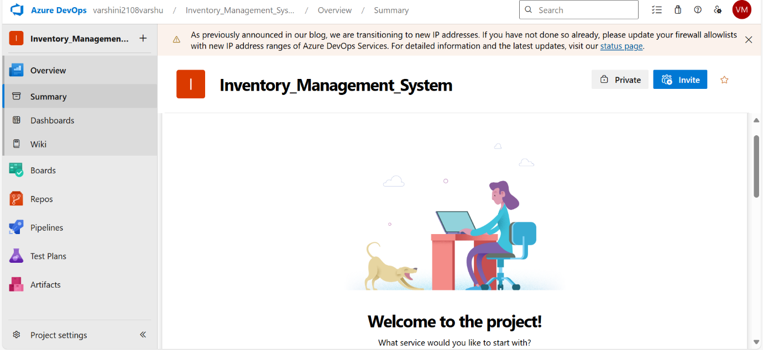

Step 3: Push Local Project to Azure Repo via SSH
In PowerShell:
cd "C:\Users\anith\OneDrive\Desktop\Inventory_Management_System\Inventory_Management_System-2"
git init
git remote add origin
git@ssh.dev.azure.com:v3/rithi31/Inventory_Management_System/Inventory_Management_System
git add .
git commit -m "Initial commit"
git push -u origin main
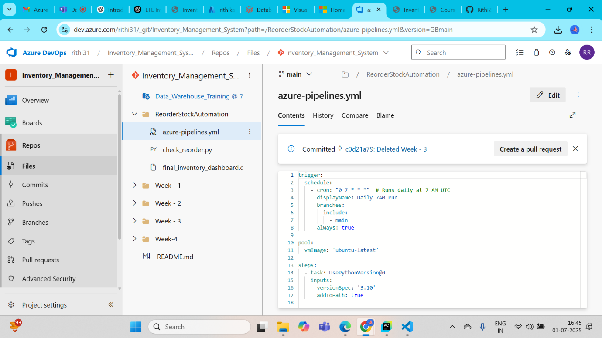

Step 4: Configure and Run Azure Pipeline
- Go to your Azure DevOps project
- Click Pipelines → Create Pipeline
- Choose:
  - Azure Repos Git
  - Select your repository
  - "Existing Azure Pipelines YAML file"
- Choose:
  - Branch: main
  - Path: /azure-pipelines.yml
- Click Continue, then Run Pipeline
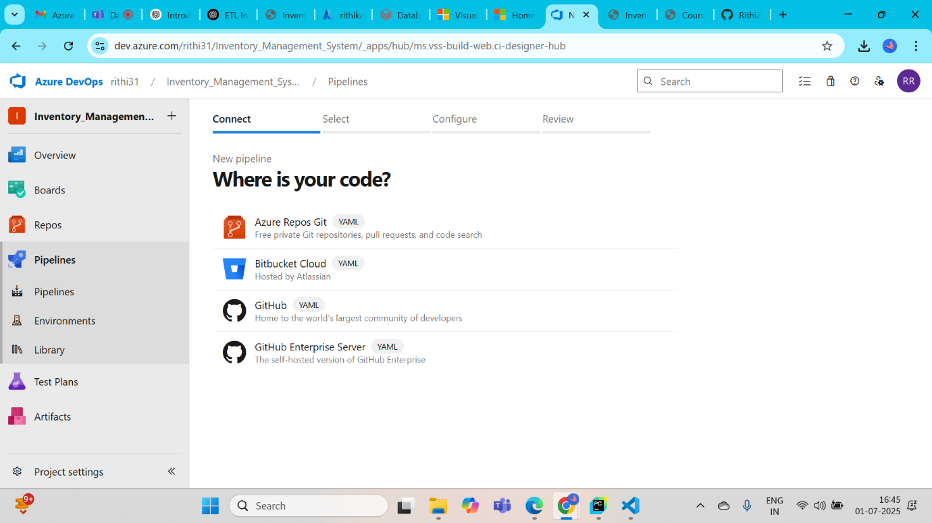

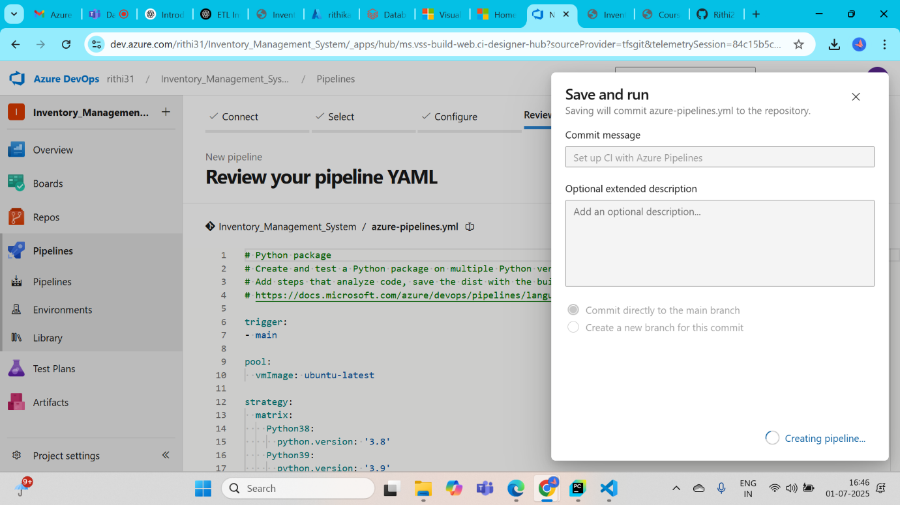

Step 5: Final Output
- The pipeline will:
  - Install dependencies
  - Run the reorder script
  - Save reorder_report.csv
